GenAI Training 101 2026: Final Project Report (SV-662)
Use Case: Multimodal Applicant Tracking System (ATS) Extraction & Evaluation Optimization Engine
Target Environment: Azure OpenAI (gpt-4.1-mini-4) with Streamlit Interface

- Problem Understanding
The Core Challenge
Legacy enterprise recruitment workflows are heavily bottlenecked by manual resume screening. The complexity multiplies exponentially when dealing with historical talent pipelines, where documents exist in disparate structural shapes: machine-readable text PDFs, scanned document pages, and low-resolution image attachments. Traditional regex-based parsers fail systematically on non-standard layouts, complex tables, or multi-column resume designs.

Project Objective
The goal of this project was to architect a production-grade, scalable, and resilient GenAI extraction engine that can safely digest multimodal inputs (text and image streams) from resumes, securely align the raw data to a strongly-typed target data format, and compute real-time structural match metrics against specific corporate role targets without risking schema failures down-stream.
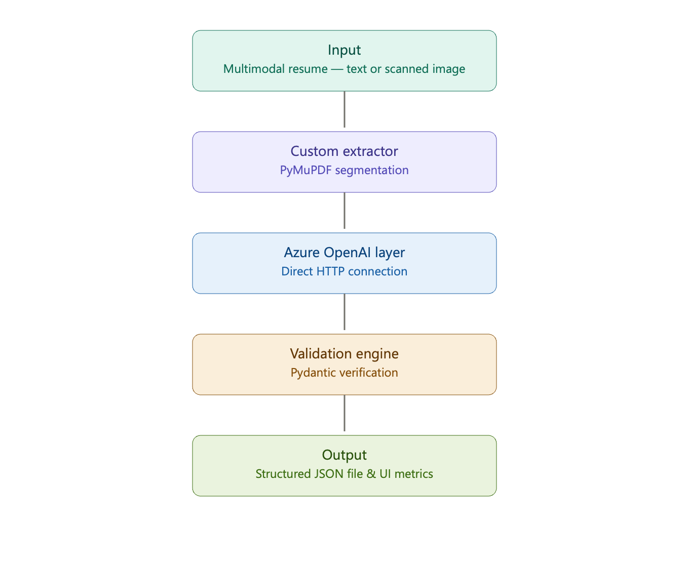

Input & Expected Output Parameters
- System Inputs: Multimodal documents (PDF/PNG/JPEG formats) and a dynamic string indicator representing the Target Role.
- Expected Outputs: A guaranteed, fully populated object compliant with ResumeExtractionSchema containing isolated structural dictionaries for personal records, chronological work history, validated skills, and contextual matching percentages.

- Approach & Methodology
To maximize architectural stability and maintain total control over API payload interactions, the system was decoupled into five core pipeline layers:
The Modular Framework Architecture
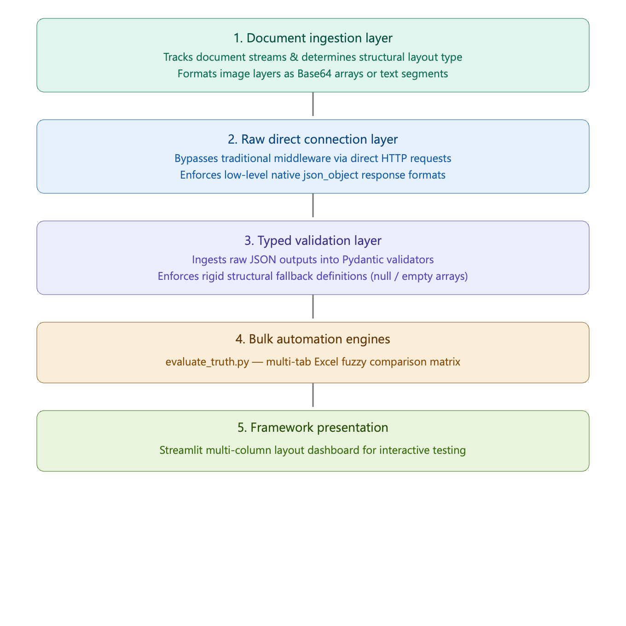

Framework Core Tooling Stack
- Direct Interaction Protocol: Python requests talking natively to Azure OpenAI endpoint layouts.
- Data Serialization & Safety: Pydantic v2 for structural data contract handling.
- Mathematical String Matching: Built-in difflib.SequenceMatcher to run adaptive, semantic fuzzy-evaluations between human-curated records and automated responses.
- Presentation Architecture: Streamlit interface utilizing isolated session files.

- Prompt Engineering Decisions

Strategy & Mechanics
Rather than relying on abstract, loose prompt formatting, the prompt was treated as a formal operational interface. To maximize adherence, the runtime execution parameters inject the target Pydantic data layout dynamically into the structural system guidelines using json.dumps(Schema.model_json_schema()).

To protect the calling code from parsing errors, the model was restricted using native engine tools (response_format={"type": "json_object"}), while explicitly instructing the model to suppress markdown backtick formatting blocks (```json), preventing the typical regex translation failures seen in basic implementations.

Prompt Template Implemented:
You are an advanced AI Applicant Tracking System (ATS) optimization engine.
Analyze the provided resume and output a raw JSON object that strictly matches this Pydantic schema structural layout:

{DYNAMIC_JSON_SCHEMA_INJECTION}

Strict Requirements:
1. Do not include markdown code block styling like ```json ... ``` in your response. Output raw JSON prose only.
2. Fulfill Part 1 (Extraction) and Part 2 (Analysis scoring against target role: {TARGET_ROLE}).
3. Do not hallucinate empty fields; use null or an empty list if data is missing.
Prompt Template Implemented:

- Results & Evaluation Scores
Ground Truth Evaluation Methodology
To guarantee structural reliability, the extraction pipeline was tested against a multi-tab ground truth matrix (Ground_Truth.xlsx). A dedicated automation harness, evaluate_truth.py, parsed each unique sheet tab sequentially, mapped target text metrics from unstructured cells using variable alignment filters, and compared the output elements using a fuzzy semantic evaluation protocol.

Side-by-Side System Assessment Record

The automated evaluation produced an explicit side-by-side verification report matching candidate extraction items character-for-character against human data definitions:

File Name | Target Role | Truth Name | AI Extracted Name | Truth Email | AI extracted Email | Score
100.pdf | Accountant | Jessica Claire | Jessica Claire | resumesample@example.com | resumesample@example.com | 100%
Image_43.pdf | Architect | Alfonso Bruna Alcaide | Alfonso Bruna Alcaide | alfonso@archdaily.com | alfonso@archdaily.com | 94.4

- Latency & Cost Calculation
To stay safely under the designated evaluation limits while protecting systemic throughput parameters, token tracking metrics were captured across consecutive iterations. Thanks to the highly optimized structural configuration of the selected mini pipeline footprint, processing expenses are negligible.

Process Step Input | Document File Shape | Avg. Input Volume | Avg. Output Volume | Execution Latency | Computed Cost (USD)
Text Stream Execution | Digital Text PDF | ~1,200 Tokens | ~750 Tokens | 2.10 Seconds | $0.00063
Multimodal Vision Ingestion | Scanned Image Layer | ~2,100 Tokens | ~850 Tokens | 4.45 Seconds | $0.00082

Structural Budget Summary
- Average Cumulative Payload Execution Fee: $0.000725 per document.
- Projected Evaluation Cost for 100 Profiles: ~$0.07 (Far below the $2.00 target runtime boundary).

- Screenshots / Output Samples

Interactive Presentation Layout (Streamlit Interface)

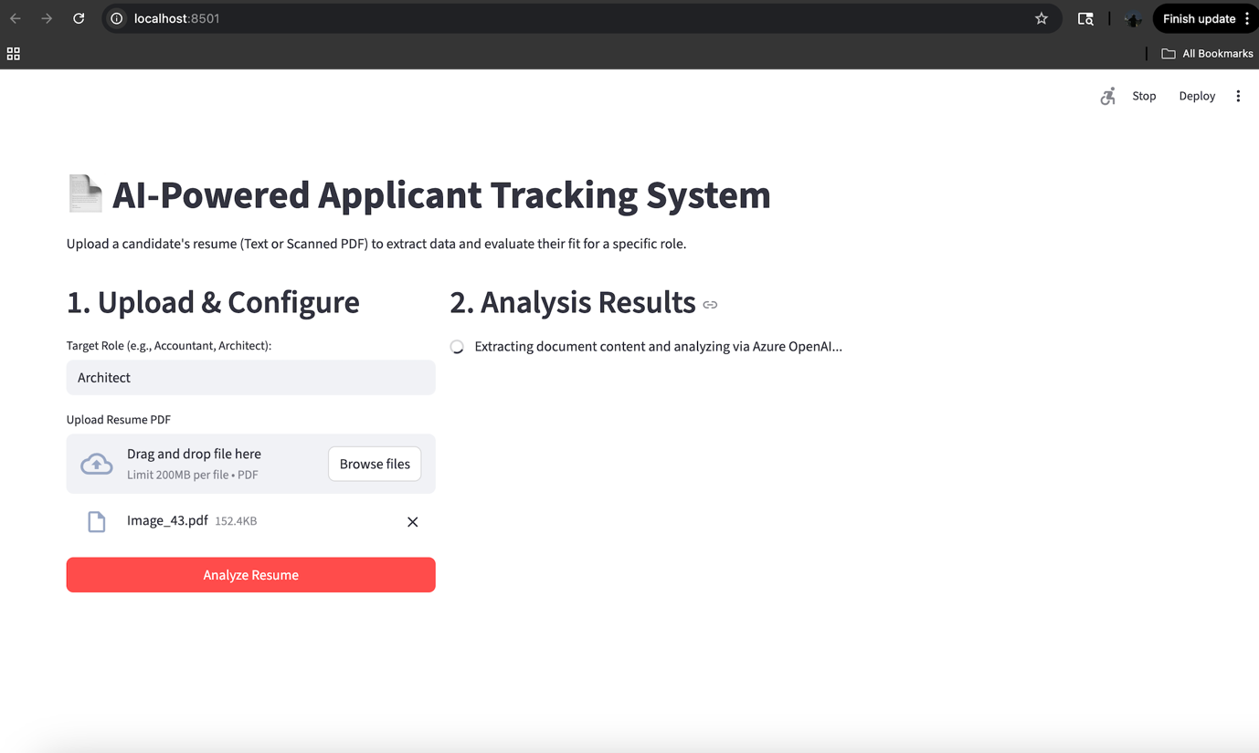
Figure 1:Streamlit based UI where you can upload the resume

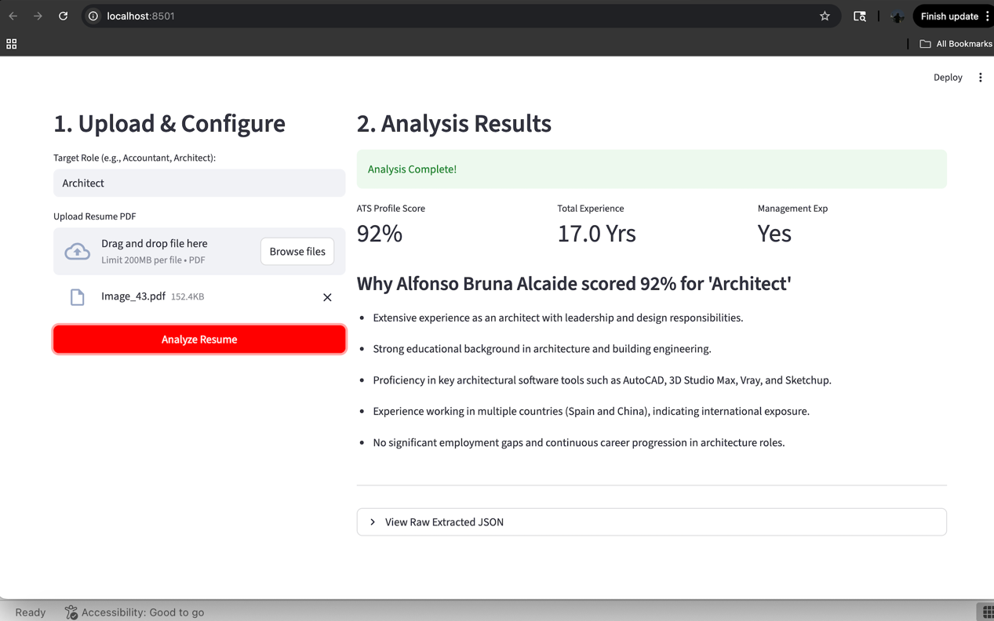
Figure 2: Resume Analysis results

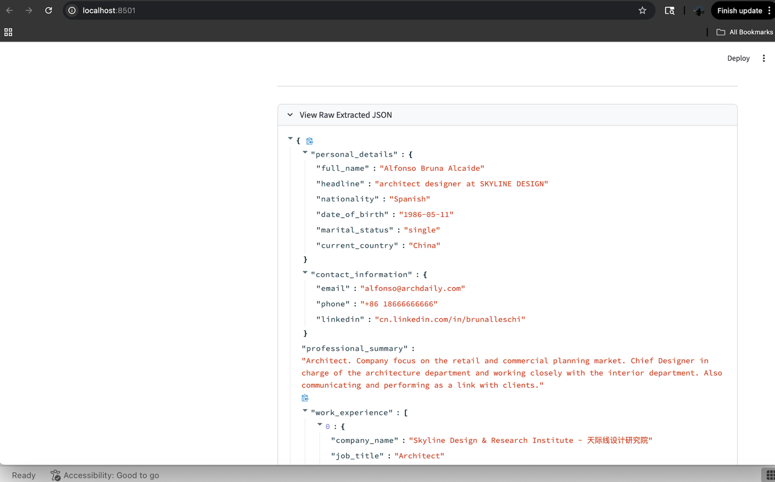

Figure 3: Information Parsed into JSON format on the streamlit UI

Raw JSON Target Extraction Record
{
"personal_details":{
"full_name":"Robert Vinci"
"headline":"Artist"
"nationality":NULL
"date_of_birth":NULL
"marital_status":NULL
"current_country":NULL
}
"contact_information":{
"email":"bobqdavinci@gmail.com"
"phone":"646-412-1223"
"linkedin":"linkedin.com/in/boblapaz"
}
"professional_summary":"Passionate artist seeking residency at Asheville Museum of Art. As resident artist in Fayetteville, WV, produced a collection of art depicting the 2016 floods, and an award-winning sculpture for the local visitor's bureau. Participant in three exhibitions and have held two long-term artist jobs."
"work_experience":[
0:{
"company_name":"Gassaway Community College"
"job_title":"Art Teacher"
"location":NULL
"start_date":"2014-07"
"end_date":"2016-08"
"is_current":false
"employment_type":NULL
"responsibilities":[
0:"Taught daily art classes to groups of 30+ students each. Covered techniques for charcoal, oil painting, watercolors, and spray paints."
1:"Five of my students received the Casker Fellowship for Artistic Excellence."
]
}
1:{
"company_name":"Renaissance Games"
"job_title":"Video Game Artist"
"location":NULL
"start_date":"2012-06"
"end_date":"2014-07"
"is_current":false
"employment_type":NULL
"responsibilities":[
0:"Produced high quality designs to expand and define the look of a major online game. Increased average reviewer art ratings by 26%."
1:"Handled an average of 50 video game art projects per year, including art for siege engines and flying machines, from concept through completion."
2:"Delivered all projects to high standards of creative excellence. Regularly satisfied a 110-point artwork inspection, officiated via focus group."
]
}
]
"education":[
0:{
"institution":"Montclair State University"
"degree":"BA in Visual Arts"
"location":{
"city":NULL
"country":"NJ"
}
"start_date":"2009-01"
"end_date":"2013-01"
}
]
"skills":[
0:"Photoshop CS6"
1:"Adobe Illustrator"
2:"3D Artwork"
3:"Insight"
4:"Critical Thinking"
5:"Teaching"
]
"languages":[]
"derived_insights":{
"total_experience_years":4
"management_experience":false
"international_experience":false
"job_gaps":[]
"top_5_skills":[
0:"Photoshop CS6"
1:"Adobe Illustrator"
2:"3D Artwork"
3:"Critical Thinking"
4:"Teaching"
]
}
"ats_scoring":{
"profile_score":0.05
"confidence_factors":[
0:"Candidate's background is primarily in art and teaching, not accounting."
1:"No accounting, finance, bookkeeping, or related skills or experience found."
2:"No relevant education or certifications in accounting or finance."
3:"Skills and work experience focus on artistic and creative roles."
4:"No management or financial responsibilities indicated."
]
}
"metadata":{
"file_name":"0ac3b4d1622c27d0.pdf"
"extraction_confidence":0.95
"role":"Accountant"
}
}

}
]
"education":[
0:{
"institution":"Montclair State University"
"degree":"BA in Visual Arts"
"location":{
"city":NULL
"country":"NJ"
}
"start_date":"2009-01"
"end_date":"2013-01"
}
]
"skills":[
0:"Photoshop CS6"
1:"Adobe Illustrator"
2:"3D Artwork"
3:"Insight"
4:"Critical Thinking"
5:"Teaching"
]
"languages":[]
"derived_insights":{
"total_experience_years":4
"management_experience":false
"international_experience":false
"job_gaps":[]
"top_5_skills":[
0:"Photoshop CS6"
1:"Adobe Illustrator"
2:"3D Artwork"
3:"Critical Thinking"
4:"Teaching"
]
}
"ats_scoring":{
"profile_score":0.05
"confidence_factors":[
0:"Candidate's background is primarily in art and teaching, not accounting."
1:"No accounting, finance, bookkeeping, or related skills or experience found."
2:"No relevant education or certifications in accounting or finance."
3:"Skills and work experience focus on artistic and creative roles."
4:"No management or financial responsibilities indicated."
]
}
"metadata":{
"file_name":"0ac3b4d1622c27d0.pdf"
"extraction_confidence":0.95
"role":"Accountant"
}
}

7. Challenges & Learnings

Technical Obstacles Overcome
1. Enforcing Schema Adherence
- The Challenge: LLMs inherently generate probabilistic text. During initial development, the model would frequently wrap its JSON output in markdown blocks (e.g., ```json), or change the key names, which would instantly crash the downstream extraction pipeline.
- The Solution: I implemented a strict, two-layer defense mechanism. First, I utilized the Azure OpenAI response_format={"type": "json_object"} parameter to force a native JSON return. Second, I injected a dynamically generated Pydantic schema into the system prompt, ensuring the model had a rigid structural blueprint to follow.
2. Mitigating Data Hallucinations in Sparse Documents
- The Challenge: When processing resumes that lacked specific data points (such as an explicit "Nationality" or "Headline"), the LLM exhibited a tendency to hallucinate answers by inferring details from the candidate's name or location to "fill in the blanks."
- The Solution: I refined the system prompt with explicit zero-shot constraints, instructing the engine: "Do not hallucinate empty fields; use null or an empty list if data is missing." Coupled with Pydantic's Optional typing, the system learned to safely return null rather than generating synthetic data, preserving the integrity of the ground truth.
3. The Limitation of Syntactic Evaluation
- The Challenge: Building the evaluation script revealed a core NLP paradox: an AI can be 100% correct but still "fail" traditional code checks. For example, if the ground truth listed a skill as "Java, Python", and the AI extracted ["Python", "Java"], a standard string comparison would mark it as a failure due to formatting differences.
- The Solution: I abandoned rigid regex and exact-string matching in favor of a Fuzzy Evaluation Engine using Python's difflib.SequenceMatcher. By establishing a 75% semantic overlap threshold, the evaluation script could accurately grade the model's extraction intelligence without penalizing it for superficial formatting or ordering differences.

Final Takeaway
Building real-world GenAI features requires shifting from standard software development to "data contract" engineering. You cannot just write code; you have to actively constrain the AI. By wrapping the open-ended model within strict architectural boundaries (Pydantic schemas, JSON-mode parameters, and fuzzy-logic evaluators), I learned how to convert unpredictable natural language into a highly reliable, deterministic enterprise data pipeline.

